**2.3 – Site Map**

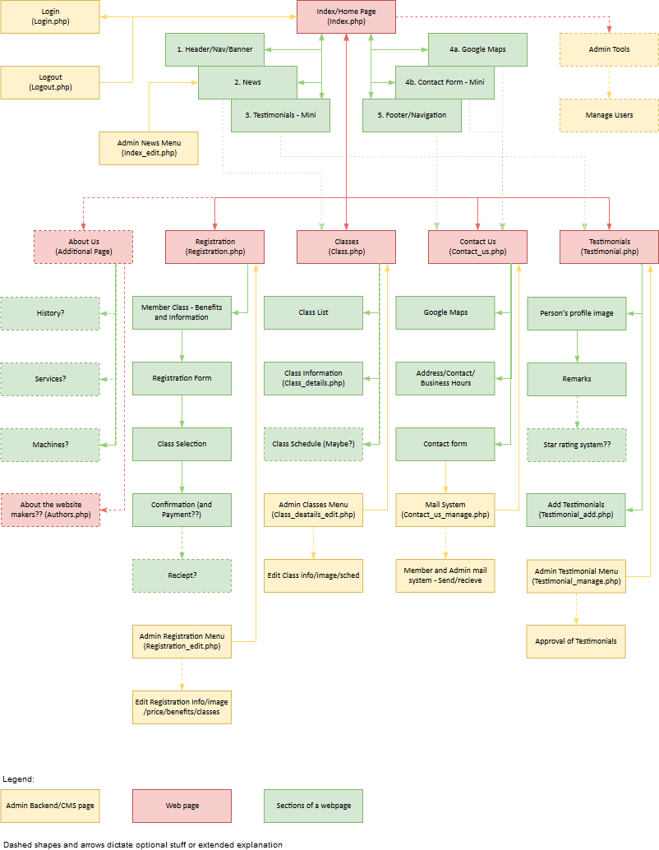

Figure 1 - Sitemap and website flow

The sitemap follows the flow of the entire system starting with the index. As you can see, the index has 6 sections; the header which has the navigation and the main banner of the site, the News section where visitors of the site can see (at least two of) the latest news. A mini testimonials section which displays some testimonials, a compact contact us section which has a google maps API integration and the contact us form, and finally, the footer which will serve as a second navigation and will house the social media handles of the website including but not limited to; twitter, Instagram and Facebook. Some of these sections will link to the actual full webpage, such as the mini contact us section; which will lead to the full contact us page. (See sitemap - Figure 1 - for full flow of the system).

The main pages along with the index, are registration, classes, contact us and testimonials. Optional pages include an about us for the fitness company and an about the authors page highlighting details about the developers. These pages have sections to them too and an admin control page that controls the content displayed on the pages. Sort of like a mini/compact content management system.

The optional “About us” page can contain many sections such as the history of the company, the machinery they use, their mentality, their business model, some other services they offer, some FAQs and links to other sections such as the contact us page should visitors of the website have any questions not answered in the FAQ section.

Global functional backend scripts/webpages such as login and logout and the user management of the admin is also included for transparency. Although the user management of the admin is optional, it is highly recommended as to manage those who can access the admin tools such as the content management pages.